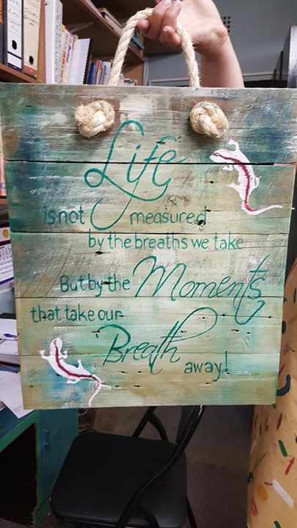

Pallet Painting Workshop

Saturday 24th October 2015

@ Whisk Restaurant, Nellmapius Drive, Irene

13:30 to 17:30

R250.00 per person (including refreshments)

17:30 Chocolate & Cheese Wine Pairing R30pp

RSVP to Wendy @ kbloy@mweb.co.za